**AI DEVELOPMENTS**

**https://24x7offshoring.com/**

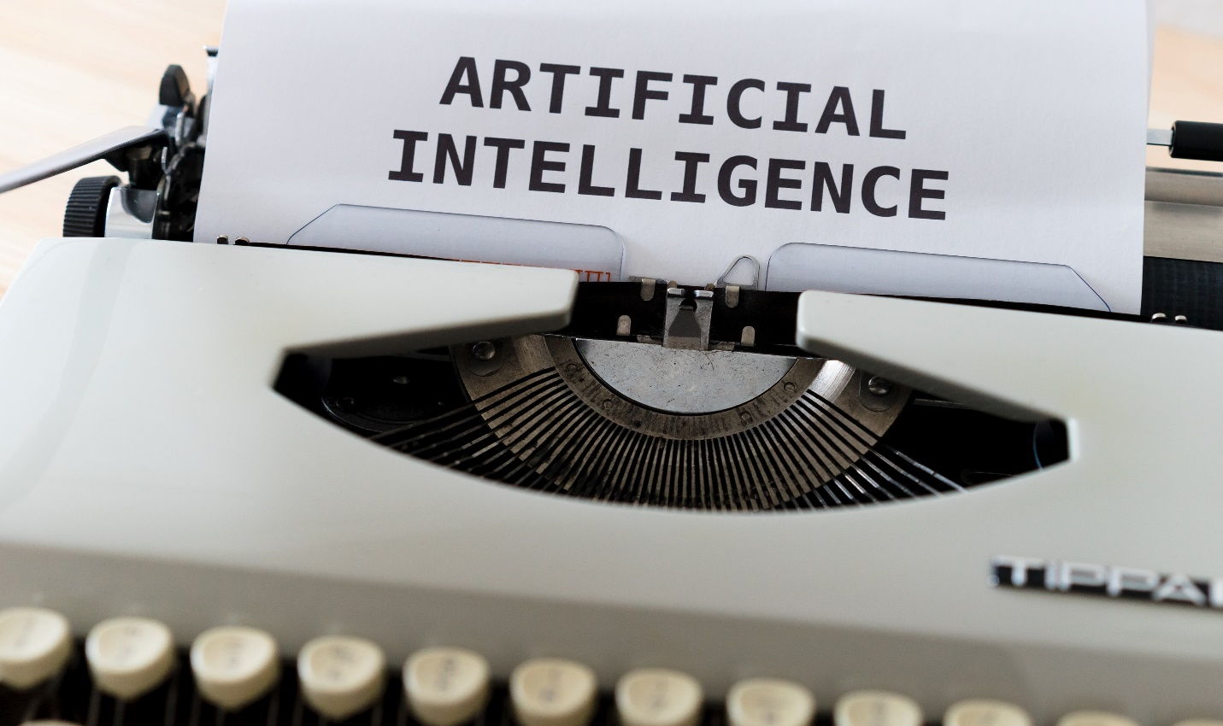[**http://24x7outsourcing.com/**](http://24x7outsourcing.com/)

**The Latest Innovations in Artificial Intelligence**

**What are probably the latest advancements in AI?**

With such countless arising applications for man-made reasoning making a sprinkle across a wide scope of ventures, it tends to be hard to keep up. This post will address some cool advances made in 2019 and take a gander at what's not too far off.

**Artificial intelligence takes a profound plunge**

Mechanical technology is a great space of advancement for the AI people group so it's nothing unexpected that there are a lot of new companies leading examination with the aim of taking the field further. Seattle organization Olis Robotics grabbed the eye of GeekWire recently with an answer intended to take mechanical technology to the following level, however elsewhere completely.

As per CEO Don Pickering, "Olis Robotics' advancement as of now shows in an attachment and-play regulator stacked with our AI-driven programming stage.

The regulator and our exclusive programming can work fastened robots on the sea floor, satellite overhauling robots utilizing high-idleness satellite connections in space, or mechanical robots tidying up a risky synthetic spill ashore utilizing 4G/5G organizations.

Our development will dramatically extend the part of robots to have an effect on human headway and investigation."

**The keen cash is on AI**

A new report by Deloitte entitled AI Leaders in Financial Services, Common attributes of Frontrunners in the Artificial Intelligence Race gives some great point of view on how AI is altering the Financial Services industry.

**The investigation reports key insights that mirror the quickly propelling utilization of AI advances:**

Leader monetary administrations firms are accomplishing companywide income development of 19% straightforwardly inferable from their AI activities, a lot more prominent than the 12% of adherent firms accomplish.

70% of firms taking part in the examination use AI underway conditions today, and 60% are utilizing Natural Language Processing (NLP).

60% of leader monetary administrations firms are characterizing AI accomplishment by upgrades to income – 47% by improving client experience.

49% of leaders have a far reaching hierarchical technique set up for AI appropriation, which divisions are relied upon to follow, giving them prompt scale and speed over rival firms.

45% of AI leader firms are putting more than $5M in AI activities today, 3X the degree of starters or late adopters.

**AI goes wild**

New AI programming created by analysts at the University of Oxford can perceive and follow the essences of individual chimpanzees in their regular territories.

The product will permit specialists and untamed life moderates to essentially scale back time and assets spent dissecting video film, as indicated by another paper.

In Science Daily, Dan Schofield, specialist and DPhil understudy at Oxford University's Primate Models Lab, School of Anthropology clarified, "For species like chimpanzees, which have complex public activities and live for a long time, getting previews of their conduct from transient field exploration can indeed disclose to us a limited amount of a lot.

By tackling the force of AI to open huge video documents, it makes it possible to gauge conduct over the long haul, for instance seeing how the social communications of a gathering change more than a few ages.'

The group at Oxford trusts the new programming will help improve protection endeavors in regions where chimpanzees are imperiled.

**AI DEVELOPMENTS**

[**https://24x7offshoring.com/**](https://24x7offshoring.com/)

[**http://24x7outsourcing.com/**](http://24x7outsourcing.com/)